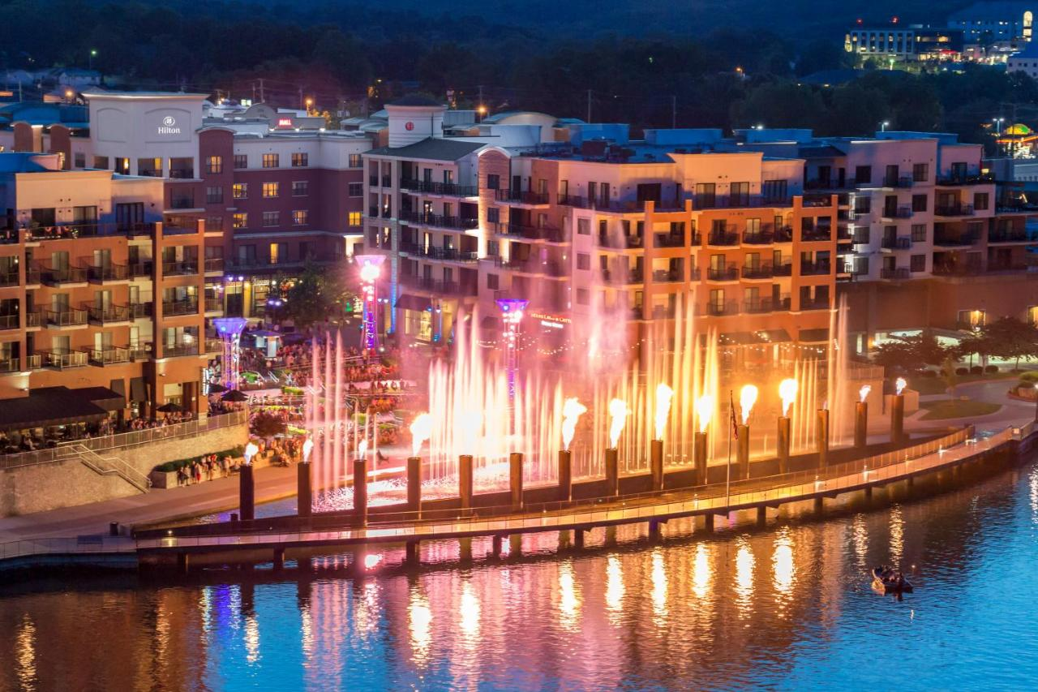
OTA 2023 SUMMER CONFERENCE
JUNE 4th – 7th, 2023
Branson Hilton Convention Center
Branson, MO

Dear OTA/ATA Members and Guests:

It’s great to be back in Branson and we all look forward to seeing everyone again. It’s been a long time and we are so excited to reconnect with our Members and their families. With all the Broadband Grant Programs being currently offered in our Industry, it is only fitting that our theme this year will be…

“Mapping a Fiber Future”

Our General Sessions will include several speakers from State and National organizations as well as representatives from our own member companies. Come learn about the latest Industry issues and explore new services for your customers and revenue opportunities for your company.

I hope you will take this opportunity to get reacquainted with old friends and to meet some new ones. We will begin Sunday evening with a Welcome Reception and Registration event and conclude Wednesday evening with the Awards Banquet.
We are also excited to have:

- Our Annual OTA Foundation Golf Tournament, which benefits the OTA Foundation Scholarship Program, will be held at 8 am on Monday, June 5th @ the beautiful Branson Hills GC (formally the Payne Stewart course). A hot breakfast and BBQ are included.

- The Suppliers’ Showcase continues to grow each year and will be a hit again. This Showcase provides a great opportunity to learn about the most recent products and services available to enhance your company’s operations.

- Our ITPA Silent Auction will continue its storied history with great auction items up for bidding. All proceeds will go towards the OTA Foundation Scholarship Fund.

- Finally, our Conference will conclude with a Cocktail Reception and our Awards Banquet where we will honor our newest Hall of Fame members and Bill Barnes Award honoree(s).

To register, please complete and email the Conference registration forms enclosed in this packet to the OTA office (tom@oklata.org) no later than Monday, May 22nd, 2023.

Your lodging deadline is Monday, May 12th, 2023.

To make your hotel reservation directly with the Branson Hilton, follow the directions below:

To expedite your reservation
- Click on the web page address in purple font below to access the Hotel Reservation Link (The link pre-populates your group code)
- Click the “Book a Room” Link
- To edit your stay for the conference, click the “Edit Stay” hyperlink.
- Make reservations as soon as possible. The special room rate will be available until Friday, May 12, 2023, or until the room block is sold-out, whichever comes first.

If you would like to spend additional days in Branson either before or after the meeting, the group rate could be offered and is BASED ON AVAILABILITY. Select the “Edit Stay” hyperlink to check availability.

Below is the official Hilton Online Link and phone reservation information for Oklahoma Rural Broadband Association 88th Annual Summer Conference:

Hotel Reservation Link:

OK Rural Broadband Assn - 88Th Summer Conference (hilton.com)

If you have any questions or need further information, please call Tom Karalis at
405-525-7700 or 918-636-1313.

Welcome Back!

Sincerely yours,

Trent LeForce
Chair, Summer Conference

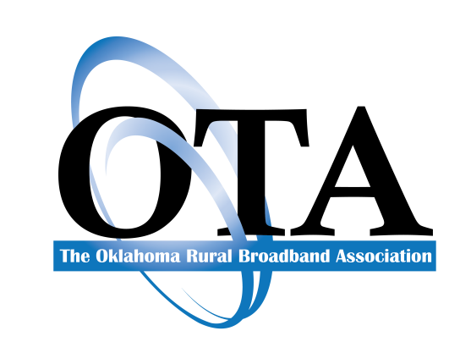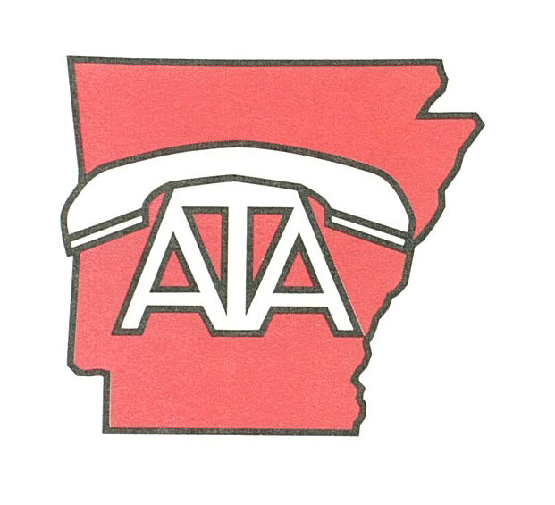

2023 OTA/ATA SUMMER CONFERENCE REGISTRATION

June 4th – 7th @ Branson Hilton Convention Center, Branson, MO

Company:________________________________________________________________________

Address:_________________________________________________________________________ City, State, Zip:____________________________________

Email Address:_________________________________________________ Telephone:_____________________ Member of (check all that apply): OTA_____ ATA____

Name | Banquet  Y or N  Wed  June 7th  6:00 PM | Employee (E)  Spouse (S)  Guest (G)  Child (C)  (6-18)  Non-Member (NM) | * Registration  $325 (E)  $150(S/G)  $100 ( C 6-18 )  $500 NM  ** | Banquet  Only  $110 | ** Golf  Register  $225  Monday  June 5th  9 AM | **Golf  Green  Sign  $150 | **Golf  T-Box  Sign  $200 | **Golf  Mulligans  3 for $30  $15 each after that | Showcase Only  $25/day | **Exhibit  $175  Mon, June 5th  6:00-8 PM  Tues, June 6th,  7:30-Noon  Wed, June 7th  7:30– Noon | Ghost  Ball | Conference  Sponsor
TOTAL
* Late Registration: After May 18th, 2023 add $50 per person to registration (not applicable for children).

Cancelations:
OTA shall not be liable for costs, fees, liquidated damages, or any other Cancellation fees including deposit forfeiture for Cancellation by the Company or OTA due to government-mandated public health requirements for travel and/or meetings. If such a cancellation is made, then deposits must be returned to the Company within thirty (30) days of Cancellation. Refunds for cancellations received after May 17, 2023, will be made at the sole discretion of OTA.

Limitation of Liability:
IN NO EVENT, EXCEPTED AS SPECIFICALLY STATED ELSEWHERE IN THIS REGISTRATION, SHALL EITHER PARTY BE LIABLE FOR ANY LOST REVENUE, LOST PROFITS, INDIRECT, SPECIAL, INCIDENTAL, CONSEQUENTIAL, OR PUNITIVE DAMAGES, HOWEVER CAUSED AND UNDER ANY THEORY OF LIABILITY, WHETHER IN CONTRACT, TORT (INCLUDING NEGLIGENCE AND STRICT LIABILITY) OR OTHERWISE, ARISING OUT OF THIS AGREEMENT, EVEN IF ADVISED OF THE POSSIBILITY OF SUCH DAMAGES, AND NOTWITHSTANDING ANY FAILURE OF PURPOSE OF ANY LIMITED REMEDY. THE COMPANY’S AND OTA’S TOTAL AGGREGATE LIABILITY HEREUNDER SHALL NOT EXCEED THE AGGREGATE FEES PAID BY THE COMPANY UNDER THIS AGREEMENT.

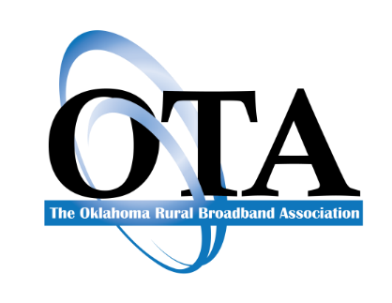

2023 Summer Conference Itinerary
Branson Hilton Convention Center

Sunday, June 4th, 2023

12noon – 4 pm Exhibitors’ Set-Up – Exhibit Hall B

6:00 – 8:00 pm Welcome Reception and Registration – CC Lobby & Courtyard

Monday, June 5th, 2023

7:30 am Golfers’ Breakfast @ Branson Hills GC
9 am Shotgun Golf Tournament @ Branson Hills GC
1:30 pm BBQ Lunch @ Branson Hills GC

12noon – 4:30 pm Exhibitors’ Set-Up – Exhibit Hall B
4:45 pm Associate Members Meeting – Exhibit Hall B
5 pm -7:00 pm Suppliers’ Reception & Showcase – Exhibit Hall B

Tuesday, June 6th, 2023

7 am – 8:30 am Suppliers’ Showcase and Buffet Breakfast – Exhibit Hall B

8:45 am GENERAL SESSION I – Taneycomo Ballroom A
Welcome – Trent LeForce, OTA President

9:00 – 9:30 am Washington DC Updates – Allison Remsen, USTelecom

9:30 – 10 am Broadband Labeling – Guy Benson, JSI

10:00 – 10:45 am Supply Chain Panel - Moderated by Dusty Harper, Finley Engineering
Howard Gorter, CT&T Engineering
Blake Callaham, Pioneer Telephone Cooperative
Ray Hunt, Clearfield
Tony Ellis, USACC

10:45 am 30 Min BREAK – Exhibit Hall B

11:15 am – 12Noon USF Panel – Moderated by Larry Jones, Chickasaw Telephone Company
Allison Remsen, USTelecom
Brian Ford, NTCA
Eric Keber, WTA

12Noon OTA MEMBERS MEETING – Taneycomo Ballroom A

12:15 pm ITPA Meeting – Fall Creek

2:00 p.m. ATA Board of Directors’ Meeting – Fall Creek

7:00 p.m. Beware the Ghost Ball

Wednesday, June 7th, 2023

7:30 – 8:30 am OTA Board of Directors’ Meeting & Breakfast – Fall Creek

7 am – 8:30 am Suppliers’ Showcase and Buffet Breakfast – Exhibit Hall B

8:45 am GENERAL SESSION DAY II – Taneycomo Ballroom A
Welcome – Day II – OTA President, Chad Segress

9:00 – 9:30 am Legislative Panel – Moderated by Mark Gailey, Totah Communications
Bill Bullard, WBFB Law
Ron Comingdeer, Comingdeer & Murer
Written remarks from Mark Argenbright, Director and OUSF Administrator, OK Commission

9:30 – 10:00 am Cloud Switching for Rural ILECs – NTCA

10 am – 10:30 am Employment Law - Womble, Bond, Dickinson

10:30 am 30 Min BREAK – Exhibit Hall B

11 – 12Noon Broadband in Oklahoma Panel – Moderated by Lynn Merrill, MRL Engineering
Oklahoma Broadband Office
Shekinah Pepper, RUS
Kevin Blake, NTIA

6:00 – 7:00 pm Hospitality Hour & ITPA Silent Auction – Taneycomo Ballroom A

7:00 p.m. Banquet & Awards Ceremony – Taneycomo Ballroom A

End of Conference
Hotel Reservation Information
Branson Hilton Convention Center
200 E Main St, Branson, MO 65616
(417) 336-5400

For those of you who require overnight accommodations, the OTA/ATA has reserved room blocks at the Hilton.
To make your reservation click on this link:

https://www.hilton.com/en/attend-my-event/hrobchh-orba23-d453b2c2-6431-4024-a567-cf82a51cd6b4/

Please make your room reservations before the cut-off date of Monday, May 15th, 2023
(All rooms are subject to applicable sales and occupancy tax.)

Parking/Transportation
Self-parking is available at no charge for all registered guests. Valet parking is available.

Internet
Complimentary Internet in guest rooms.

OTA/ATA
SPONSORSHIP AND DONATIONS

Your sponsorship of cash and prizes is needed for the 2023 Summer Conference. There are five levels of sponsorship that give your company an opportunity to receive recognition throughout the conference through signage and announcements. These sponsorships support the drawings at the two General Sessions and Banquet as well as partially underwriting conference expenses.

The levels of sponsorship are as follows:
Corporate Sponsor $ 5,000 and above Gold Sponsorship $301 to $500
Platinum Sponsor $ 1,000 to 4,999 Silver Sponsorship $100 to $300
Emerald Sponsor $ 501 to $ 999

Other cash donations and non-monetary items are also welcome. If your company wishes to be a sponsor or to make a donation, please complete this form and return it with your registration material no later than Monday, May 15th, 2023.

If your donation is an item (not monetary), please take it, along with your business card attached, to the Conference registration table on Wednesday, June 7^{th,} and deliver it to the OTA Staff.

Type of Sponsorship or Donation:

Corporate $5000+ $ _______ Gold $300 - $500 $________
Platinum $1000 - $4999 $ _______ Silver $100 - $300 $________
Emerald $500 - $4999 $ _______

Company Name: ____________________________________________

Address: ____________________________________________

City: _________________________________ St. ______ Zip ___________

Member of (check all that apply): OTA____________ ATA___________

THANK YOU FOR YOUR SUPPORT OF THE
OKLAHOMA TELEPHONE ASSOCIATION and
ARKANSAS TELECOMMUNICATIONS ASSOCIATION

BRANSON HILLS GC
100 North Payne Stewart Dr. Branson, MO
(417) 337-2963

Monday June 5th, 2023
8 am Breakfast
9 am Shotgun Start

2023 OTA FOUNDATION SCHOLARSHIP BENEFIT GOLF TOURNAMENT REGISTRATION FORM

- Registration fees per player are $225.00, including a green fee, golf cart, hot breakfast, beverages, and a BBQ lunch.
- Branson Hills GC is approximately 9 miles (15 minutes) from the Hilton Hotel
- Transportation will NOT be provided to and from the golf course.
- Players are encouraged to purchase mulligans in advance on this registration form.
- Mulligans are 3 x $30 and $15 for each additional one.
- All ties will be resolved by the Country Club golf professional.
- Players are not allowed to wear denim.
- Collared shirts and soft golf spikes are required.

Golf Registration:

Company Name: ________________________________________________________
Participant(s) Name: 1. _______________________________________________ HDCP: ____________
2. _______________________________________________ HDCP: ____________
3. _______________________________________________ HDCP: ____________

Golf Registration: $225 Amount $ __________
Mulligans: 3 @ $30 Amount $ __________
Additional Mulligans: $15 each Amount $___________

TOTAL: $_____________________

Sponsorship Opportunities
This tournament provides a good opportunity for you to show your support while receiving recognition by completing the sponsorships area below. As in previous years, you can purchase sponsorships for green-side and/or tee box signs with your company’s name.

Space may be limited, so please return this completed form with your registration to the OTA office no later than May 22^{n}, 2023.

On Course Sponsorships

Tee Box Sign: $200.00 per sign
Number of Signs: __________ Amount: $ __________

Green Side Sign: $150.00 per sign
Number of Signs: __________ Amount: $ __________

Total Golf Registration:
Amount $ __________

Name to appear on sign: ____________________________________________________
The 22nd Annual
Oklahoma Telephone Association Foundation
2023 Ghost Ball

Don’t save the date. Don’t worry about the time. Don’t worry about your attire.
This PHANTOM event is a 100% tax-deductible fund-raiser for the OTA Foundation. The Ghost Ball enables the Foundation to provide scholarships for dependents of Oklahoma-based telephone company employees who attend a university, college, or career tech in Oklahoma. We hope you will respond generously in supporting the Foundation.

WHERE: Ghostville, USA
Tickets: $500 per table of 10
$150 per couple / $100 per single ticket
Any amount is appreciated.

Company Name: ______________________________________
Contribution Amount: _________________________________

In 2022, the OTA Foundation awarded 48 scholarships of $750 each, to dependents of OTA member companies’ employees, totaling $36,000. These awards were made possible by your generous donations.

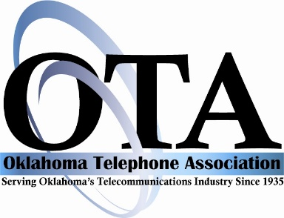
BILLING AUTHORIZATION FORM
I authorize you to charge my bill directly to the credit card listed below:

Company Name:__________________________________________________________

Charge to: _____ Visa _____ Discover _____ MasterCard _____AmEx

Card #______________________________________________ Exp. Date:_________

Print Cardholder’s Name:___________________________________________________

Billing Address:___________________________________________________________

City:__________________________________ State:____________ Zip_________

Total Amount to be Charged: _________________________________

EXHIBITOR / VENDOR
INFORMATION

Please see the attachments included in your email if you need additional items.

Included in your exhibitor fee of $175.00 is:
- 8’x10’ Exhibit Space with pipe & drape
- 6’ skirted table
- 2 chairs
- Wastebasket
- ID Sign

For Exhibit shipping information, please call:
Brian Hissink @ 417.237.4004

